A

Mini Project Report on

## Agri Genius –Intelligent Farming Solution

## using Deep Learning

Submitted in partial fulfillment of the requirements for the degree of

BACHELOR OF ENGINEERING

IN

### Computer Science & Engineering

### Artificial Intelligence & Machine Learning

### by

Aaryaman Kattali (22106077)

Vaishnavi Dumbre (22106115)

Durvesh Kanade (22106013)

Sidra Khan (22106028)

**Under the guidance of**

## Prof. Vijaya Bharathi Jagan

### Department of Computer Science & Engineering

### (Artificial Intelligence & Machine Learning)

**A. P. Shah Institute of Technology**

**G. B. Road, Kasarvadavali, Thane (W)-400615**

**University Of Mumbai**

**2024-2025**



**CERTIFICATE**

This is to certify that the project entitled “**Agri Genius –Intelligent Farming Solution using Deep Learning”** is a bonafide work of Aaryaman Kattali (22106077), Vaishnavi Dumbre (22106115), Durvesh Kanade (22106013), Sidra Khan (22106028) submitted to the University of Mumbai in partial fulfillment of the requirement for the award of **Bachelor of Engineering** in **Computer Science & Engineering (Artificial Intelligence & Machine Learning).**

|  |  |
| --- | --- |
| _______________________ | _______________ |
| Prof. Vijaya Bharathi Jagan | Dr. Jaya Gupta |
| Mini Project Guide | Head of Department |

|  |  |
| --- | --- |
|  |  |
|  |  |



**Project Report Approval**

This Mini project report entitled “**Agri Genius-Intelligent Farming Solution Using Deep Learning*”*** by**Aaryaman Kattali , Vaishnavi Dumbre , Durvesh Kanade and Sidra Khan** is approved for the degree of ***Bachelor of Engineering*** in ***Computer Science &Engineering***, (AI&ML) ***2024-25***.

External Examiner:

Internal Examiner:

Place: APSIT, Thane Date:

## DECLARATION

We declare that this written submission represents my ideas in my own words and where others' ideas or words have been included, I have adequately cited and referenced the original sources. I also declare that I have adhered to all principles of academic honesty and integrity and have not misrepresented or fabricated or falsified any idea/data/fact/source in my submission. I understand that any violation of the above will be cause for disciplinary action by the Institute and can also evoke penal action from the sources which have thus not been properly cited or from whom proper permission has not been taken when needed.

|  |  |  |  |
| --- | --- | --- | --- |
| Aaryaman Kattali | Vaishnavi Dumbre | Durvesh Kanade | Sidra Khan |
| (22106077) | (22106115) | (22106013) | (22106028) |

## ABSTRACT

Agriculture is the backbone of the global economy, yet traditional farming methods often struggle with inefficiencies, climate unpredictability, pest infestations, and resource mismanagement. Agri Genius—Intelligent Farming Solution integrates Deep Learning with smart agriculture to address these challenges through advanced artificial intelligence techniques. This system utilizes a custom ResNet-inspired CNN architecture for plant disease detection and combines it with a Retrieval-Augmented Generation (RAG) chatbot powered by the Mistral-7B-Instruct model. By analyzing RGB images of plant leaves and maintaining a comprehensive knowledge base of disease information, Agri Genius provides automated, precise, and actionable insights to farmers. The solution enhances decision-making in disease identification, treatment recommendations, and prevention strategies, leading to higher productivity, cost efficiency, and sustainable farming practices. Additionally, the system employs batch normalization, residual connections, and gradient clipping to ensure training stability and model performance. Through its Gradio-based interface, Agri Genius revolutionizes plant health management, empowering farmers with an integrated approach that combines computer vision for disease detection with conversational AI for expert agricultural advice.

**Index**

|  |  |  |  |
| --- | --- | --- | --- |
| Index | | | Page no. |
| Chapter-1 | | | 1 |
|  | Introduction | | 2 |
| Chapter-2 | | | 3 |
|  | Literature Survey | | 4 |
|  | 2.1 | History | 4 |
|  | 2.1 | Review | 6 |
| Chapter-3 | | | 7 |
|  | Problem Statement | | 8 |
| Chapter-4 | | | 9 |
|  | Experimental Setup | | 10 |
|  | 4.1 | Model Architecture | 11 |
|  | 4.2 | Tools and Libraries | 12 |
| Chapter-5 | | | 13 |
|  | Proposed system and Implementation | | 13 |
|  | 5.1 | Block diagram of proposed system | 13 |
|  | 5.2 | Description of block diagram | 13 |
|  | 5.3 | Implementation | 15 |
| Chapter-6 | | | 16 |
|  | Conclusion | | 17 |
| References 18 | | | |

# CHAPTER 1 INTRODUCTION

## INTRODUCTION

Agriculture faces numerous challenges such as delayed disease detection, pest infestations, and inefficient decision-making due to a continued reliance on manual observation and traditional practices. These limitations can lead to severe crop damage, reduced yield, and economic losses for farmers. As global food demand rises, there is an urgent need for innovative, accessible, and scalable solutions that enhance agricultural productivity and sustainability.

AgriGenius addresses these critical issues by leveraging computer vision, deep learning, and conversational AI to automate plant disease detection and provide expert guidance. The system uses a custom Convolutional Neural Network (CNN) model trained on the New Plant Diseases Dataset (Augmented) to classify a wide range of plant diseases with high accuracy. Images are processed in real-time through a user-friendly Gradio web interface, where farmers can upload photos of affected leaves and receive instant diagnostic results.

To further support farmers beyond classification, AgriGenius integrates a Retrieval-Augmented Generation (RAG) chatbot. Powered by a FAISS-based retrieval system and the Mistral-7B large language model, the chatbot offers in-depth insights on each detected disease, including symptoms, treatments, and prevention strategies. This allows users to interactively ask questions and get actionable advice in natural language.

By combining AI-based image classification with a knowledge-rich chatbot, AgriGenius simplifies disease diagnosis and empowers farmers with reliable, real-time guidance—bridging the gap between advanced technology and practical agricultural support.

# CHAPTER 2 LITERATURE SURVEY

## 2. LITERATURE SURVEY

### 2.1 History

The application of artificial intelligence and deep learning in agriculture has undergone significant transformation over the past two decades, revolutionizing traditional farming methods into data-driven intelligent farming solutions. Initially, agriculture relied on conventional practices such as manual inspection, expert consultation, and remote sensing through satellite imagery, which, although useful, were time-consuming and often inaccurate due to human error. In the early 2000s, machine learning techniques such as support vector machines, decision trees, and artificial neural networks began gaining traction in the agricultural sector. These models allowed for better crop classification, soil fertility analysis, and early disease detection; however, they still relied heavily on manual feature extraction and lacked real-time analytical capabilities. Researchers soon realized the need for automated, scalable, and highly accurate systems that could continuously learn and adapt to new agricultural challenges.

With the rise of deep learning in the 2010s, particularly with the advent of convolutional neural networks (CNNs), the agricultural industry saw a paradigm shift in how data was processed and utilized for precision farming. Deep learning models eliminated the need for manual feature extraction by enabling end-to-end learning, where the algorithm could automatically detect patterns in images, sensor data, and satellite imagery. The introduction of architectures such as AlexNet in 2012, followed by more sophisticated models like GoogleNet, VGGNet, and ResNet, led to breakthroughs in image-based disease detection, pest identification, and yield prediction. By training these models on large datasets of crop images, researchers were able to classify plant diseases with remarkable accuracy, surpassing traditional expert-driven diagnostic methods. Furthermore, transfer learning techniques allowed for deep learning models to be fine-tuned with limited agricultural datasets, making AI-based crop health monitoring more accessible to small-scale farmers. However, challenges such as high computational costs, dataset limitations, and the need for large-scale implementation remained significant barriers to widespread adoption.

From 2016 onwards, AI-powered smart farming solutions integrated real-time data collection through the Internet of Things (IoT), cloud computing, and mobile applications. This integration enabled farmers to monitor soil conditions, temperature, humidity, and pest infestations in real time, providing instant decision-making capabilities. Mobile-based AI applications empowered Furthermore, RCMS prioritizes healthcare data security and regulatory compliance, ensuring farmers with instant disease diagnosis by simply capturing images of affected crops, reducing dependency on agricultural experts and minimizing crop losses. Automated irrigation systems and AI-powered drones further enhanced efficiency by optimizing water and pesticide usage, leading to cost savings and environmental sustainability. Studies showed that deep learning-based solutions improved farming productivity while reducing resource wastage. However, despite these advancements, challenges such as the need for farmer-friendly interfaces, affordability of AI solutions, and data security concerns remained prevalent.

In recent years, research has focused on the development of self-learning AI models that require minimal labeled data for training. Few-shot learning and self-supervised learning techniques have enabled models to adapt to new crop varieties and regional agricultural conditions without extensive retraining. Additionally, reinforcement learning algorithms are being applied in autonomous farming systems to optimize irrigation schedules, fertilizer distribution, and harvesting processes. AI-driven robotics, such as autonomous tractors and drone-based pesticide sprayers, are paving the way for fully automated farms. Cloud-based AI platforms are further revolutionizing precision agriculture by enabling large-scale monitoring of agricultural lands, allowing farmers to access real-time insights through mobile and web applications. Moreover, AI-powered climate-resilient models are helping farmers prepare for extreme weather conditions by predicting droughts, floods, and heatwaves, thereby mitigating risks associated with climate change.

Despite these groundbreaking advancements, several challenges still need to be addressed for the widespread adoption of AI-driven farming solutions. One of the primary challenges is the availability of high-quality, region-specific datasets that can generalize well across different climatic conditions and crop varieties. Many deep learning models suffer from bias when trained on limited datasets, leading to reduced accuracy when deployed in real-world farming environments. Additionally, the cost of implementing AI-powered solutions remains a concern for small and medium-scale farmers, particularly in developing countries. The reliance on cloud computing infrastructure raises concerns regarding data privacy, as sensitive farm data needs to be securely stored and processed. Future research in AI-driven agriculture should focus on making deep learning models more lightweight and efficient, enabling their deployment on edge devices such as low-power IoT sensors and mobile phones. Furthermore, there is a need for collaborative efforts between AI researchers, agricultural scientists, and policymakers to develop farmer-friendly interfaces and training programs to enhance AI adoption in the agricultural sector. The evolution of AI in farming has demonstrated its potential to enhance productivity, optimize resource management, and minimize losses caused by pests, diseases, and environmental factors. As research continues to advance, the future of agriculture is expected to move towards fully autonomous and sustainable farming practices, where AI-driven decision-making, robotic farming, and climate-adaptive models work in unison to create a resilient and efficient agricultural ecosystem. With continuous advancements in deep learning, AI-powered intelligent farming solutions will not only improve food security but also contribute to sustainable and environmentally friendly agricultural practices. The integration of AI in agriculture represents a transformative shift, paving the way for a future where precision, automation, and data-driven insights redefine the global farming landscape.

### 2.2 Review

|  |  |  |
| --- | --- | --- |
|  | **Title** | **Description** |
| **[1]** | A Comprehensive Crop Recommendation System Integrating Machine Learning and Deep Learning Models (2024) | This study proposes a crop recommendation system using ML and DL to help farmers optimize yields based on soil and environmental factors |
| **[2]** | Productive Crop Field Detection: A New Dataset and Deep Learning Benchmark Results (2023) | This study introduces a dataset for crop field detection and benchmarks deep learning models to improve precision agriculture |
| **[3]** | Crop Disease Detection Using Deep Learning (2019) | This study develops a deep learning model using a public dataset of crop leaf images to classify diseases, showcasing AI’s role in plant diagnostics |
| **[4]** | Crop Mapping from Image Time Series: Deep Learning with Multi-Scale Label Hierarchies (2021) | This research employs deep learning and satellite image time series for crop mapping, using multi-scale label hierarchies to enhance crop classification over time. |
| **[5]** | Comprehensive Review on Machine Learning Algorithms for Plant Disease Detection (2024) | This paper reviews ML and DL techniques for plant disease detection, highlighting their advantages over manual methods and comparing recent deep learning models. |

# CHAPTER 3 PROBLEM STATEMENT

## PROBLEM STATEMENT

Plant diseases pose a major threat to crop yields and food security, especially for smallholder and rural farmers who often lack access to timely and accurate diagnosis tools. Traditional detection methods depend on manual inspection and expert consultation, which are time-consuming, expensive, and impractical for widespread use. These limitations often result in delayed treatment, excessive pesticide use, and increased economic losses.

To address these challenges, this project introduces AgriGenius—an AI-powered plant disease detection system that utilizes deep learning and computer vision to deliver fast, image-based diagnosis of plant diseases. Complemented by a Retrieval-Augmented Generation (RAG) chatbot, the system also provides personalized treatment recommendations and preventive strategies, empowering farmers with expert-level guidance and promoting efficient, sustainable agricultural practices.

# CHAPTER 4 EXPERIMENTAL SETUP

## EXPERIMENTAL SETUP

### 4.1 Model Architecture

### Model Type: Custom CNN with ResNet-inspired architecture called CNN_NeuralNet in place of the Random Forest Classifier.

### Input Features: The model takes RGB images of plant leaves transformed to tensors with size 256×256×3 as input features.

### Output Layer: The output layer has multiple classes corresponding to different plant diseases (e.g., "Apple___Apple_scab", "Tomato___Late_blight").

### Hyperparameters

### Training Configuration: Uses Adam optimizer with a learning rate of 0.01, weight decay of 1e-4, and gradient clipping at 0.15 to ensure stable training over 5 epochs.

### Data Processing: Processes images in batches of 32 with OneCycleLR scheduler for optimized learning rate adjustment throughout the training process.

### Training Process

### Loss Function: Cross-entropy loss for multi-class classification

### Metrics: Accuracy for evaluation

### Training/Validation Split: Using separate train and validation directories

### Overfitting Handling: Includes BatchNorm layers and residual connections to improve generalization

### Testing and Validation

### Test Dataset: Separate test directory located in /test

### Validation Strategy: Using a pre-defined validation set

### Validation Metrics: Validation loss and accuracy are monitored

### 4.2 Tools and Libraries

### PyTorch & Torchvision

### Purpose: Deep learning framework for building and training neural networks

### Uses in Plant Disease Detection:

### Model Training: Building and training the custom CNN architecture

### Data Loading: Creating efficient data loaders with appropriate transformations

### Optimization: Implementing learning rate scheduling and gradient clipping

### Gradio

### Purpose: Creating interactive web interfaces for machine learning models

### Uses in Plant Disease Detection:

### Image Upload: Allowing users to upload images for real-time disease detection

### Chat Interface: Enabling users to ask questions about detected diseases

### Result Display: Presenting model predictions and disease information

### LangChain & FAISS

### Purpose: Building and deploying RAG (Retrieval-Augmented Generation) systems

### Uses in Plant Disease Detection:

### Knowledge Base: Storing comprehensive information about plant diseases

### Retrieval System: Using FAISS vector store with sentence-transformer embeddings

### LLM Integration: Connecting with Mistral-7B-Instruct model for text generation

### NumPy and PIL

### Purpose: NumPy for numerical computations and PIL for image processing

### Uses in Plant Disease Detection:

### Image Preprocessing: Resizing and normalizing images for model input

### Data Manipulation: Handling tensors and arrays for model training

### Visualization: Displaying images and results

# CHAPTER 5 PROPOSED SYSTEM AND

**IMPLEMENTATION**

## 5. PROPOSED SYSTEM AND IMPLEMENTATION

### 5.1 Block diagram of proposed system

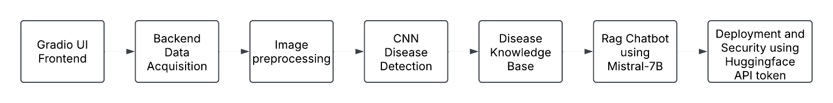

#### Fig 5.1: Block Diagram

#### **5.2 Description of block diagram**

1. **Data Acquisition and Preparation**

* Import required libraries for model development and data handling
* Import dataset from Kaggle (New Plant Diseases Dataset)
* Preprocess data using PyTorch, NumPy, and Pandas libraries for image transformation
* Images are augmented with random rotations, flips, and scaling for better generalization.

1. **Model Training Infrastructure**

* Utilize GPU for accelerated processing and computation
* Train and evaluate custom CNN model with ResNet-inspired architecture
* Convolution Neural Network(CNN) are deep learning models designed to process grid like data such as images using convolution layers
* ResNet is a CNN architecture that uses skip connections to enable training of very deep networks without vanishing gradients
* Implement batch processing and optimization strategies

1. **Disease Classification Logic**

* Binary decision point to determine if leaf is healthy or diseased
* Route images to appropriate result display based on classification outcome
* Process multiple disease classes across different plant species

1. **User Interface Implementation**

* Display classification results through Gradio web interface
* Show specific disease label or healthy status of the identified leaf
* Present results in user-friendly format for immediate understanding

1. **Information Retrieval System**

* Connect classification results to RAG (Retrieval-Augmented Generation) chatbot
* RAG combines document retrieval with generation to produce more informed and context aware responses
* Provide disease information, treatment recommendations, and solutions via LangChain
* Utilize HuggingFace for LLM integration and FAISS for efficient vector search

1. **Dataset Collection**

* **Dataset Source**: New Plant Diseases Dataset from Kaggle, downloaded via kagglehub.dataset_download("vipoooool/new-plant-diseases-dataset").
* **Data Format**: RGB images of plant leaves organized into folders representing different diseases
* **Dataset Structure**
  + Training data: Located in /New Plant Diseases Dataset(Augmented)/train
  + Validation data: Located in /New Plant Diseases Dataset(Augmented)/valid
  + Test data: Located in /test
* **Classes**: Multiple disease classes across different plant species (e.g., "Apple___Apple_scab", "Tomato___Late_blight").
* **No. of classes** : 38
* **No. of images** : 87k
* **Dataset splitting ratio (Training : Testing)** – 80:20

1. **Hyperparameter Tuning**

* Model is trained using the Adam optimizer with a learning rate of 0.01, weight decay of 1e-4 and gradient clipping set to 0.15 to stabilize training
* OneCycleLR scheduler is used to adjust the learning rate dynamically during training for faster convergence within 5 epochs
* Model trains with a batch size of 32 allowing efficient memory usage and gradient updates

### 5.3 Implementation

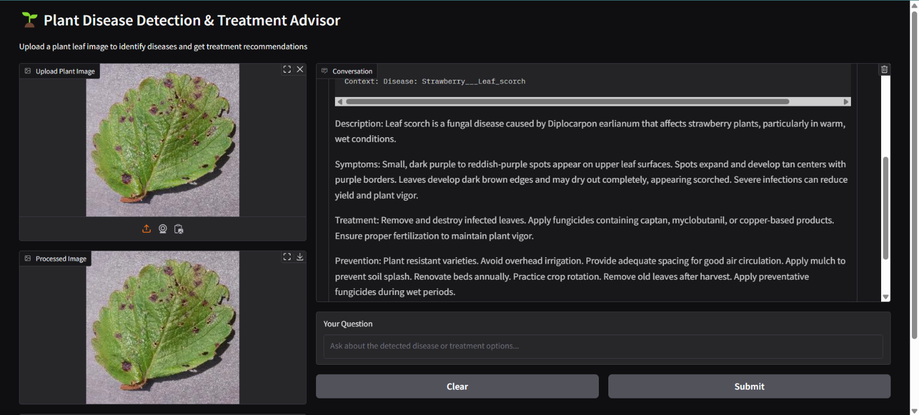

#### Fig 5.3(a): Output – Strawberry Leaf Scorch

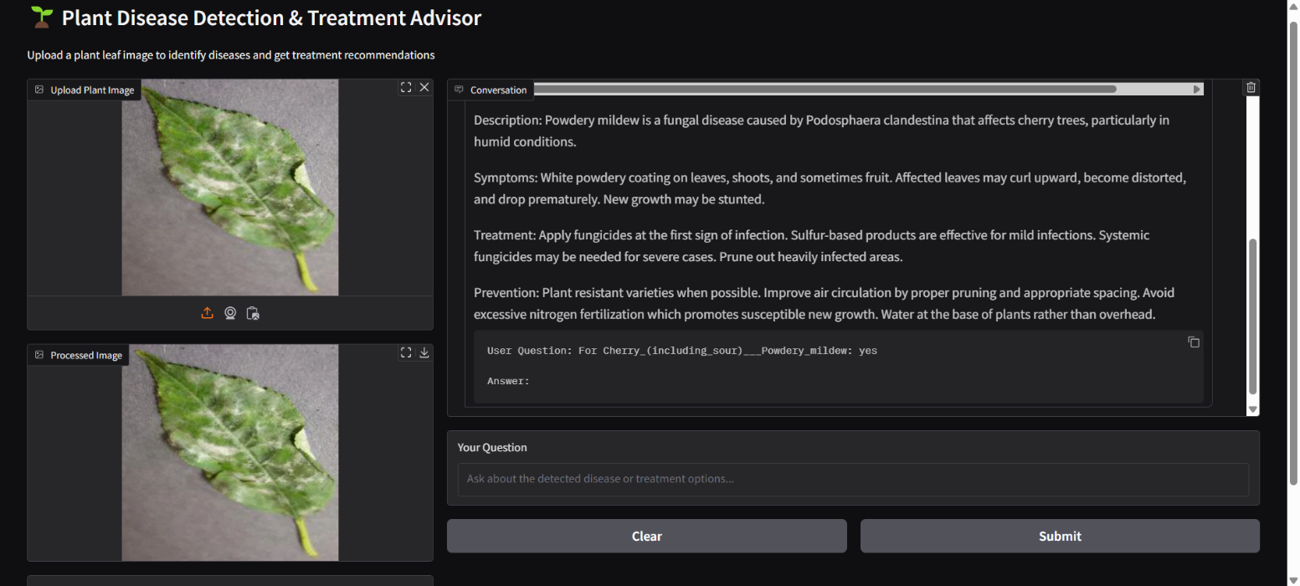

#### Fig 5.3(b): Output – Cherry Powdery Mildew

# CHAPTER 6 CONCLUSION

## 6. CONCLUSION

## AgriGenius directly addresses key challenges in agriculture, such as delayed disease detection, inefficient resource management, and the over-reliance on manual observations, by harnessing the power of deep learning and real-time image analytics. Traditional methods are often time-consuming and inaccessible to smallholder farmers. AgriGenius replaces these outdated practices with a data-driven solution that uses Convolutional Neural Networks (CNNs) to detect plant diseases, pest infestations, and nutrient deficiencies at early stages through high-resolution crop images.

## Additionally, by integrating Recurrent Neural Networks (RNNs) and Long Short-Term Memory (LSTM) models, the system analyzes historical climate and crop data to provide timely recommendations for planting, irrigation, and harvesting schedules. Its user-friendly mobile interface delivers immediate feedback and actionable insights, making advanced agricultural intelligence both accessible and practical, even for farmers in remote areas. By transforming agriculture into a predictive, AI-powered process, AgriGenius improves crop health, increases yield, and fosters sustainable farming practices.

## Looking ahead, AgriGenius has the potential to evolve into a comprehensive digital farming platform. This can be achieved by incorporating region-specific crop datasets, expanding support for multiple local languages, and adding market trend analysis to assist farmers in making economic decisions. Future advancements, such as integrating satellite-based climate predictions and continually training the AI models with diverse field data, will enhance the system’s accuracy and adaptability across different geographies. With these upgrades, AgriGenius can become an all-encompassing intelligent assistant for farmers, driving the future of precision agriculture and contributing to global food security.

17

## REFERENCES

### Research paper

**[1]** A. Ghosh, S. K. Mohapatra, P. Pattanaik, P. K. Dash and S. Chakravarty, "A Comprehensive Crop Recommendation System Integrating Machine Learning and Deep Learning Models," *2024 1st International Conference on Cognitive, Green and Ubiquitous Computing (IC-CGU)*, Bhubaneswar, India, 2024, pp. 1-6, doi: 10.1109/IC-CGU58078.2024.10530724

**[2]** Nascimento, E., Just, J., Almeida, J., & Almeida, T. (2023). Productive Crop Field Detection: A New Dataset and Deep Learning Benchmark Results. *IEEE Geoscience and Remote Sensing Letters*.

**[3]** O. Kulkarni, "Crop Disease Detection Using Deep Learning," *2018 Fourth International Conference on Computing Communication Control and Automation (ICCUBEA)*, Pune, India, 2018, pp. 1-4, doi: 10.1109/ICCUBEA.2018.8697390

**[4]** Turkoglu, M. O., D'Aronco, S., Perich, G., Liebisch, F., Streit, C., Schindler, K., & Wegner, J. D. (2021). Crop mapping from image time series: deep learning with multi-scale label hierarchies. arXiv preprint arXiv:2102.08820

**[5]** P. Yerunkar, A. Ganer and K. Kalbande, "Comprehensive Review on Machine Learning Algorithms for Plant Disease Detection," *2024 Parul International Conference on Engineering and Technology (PICET)*, Vadodara, India, 2024, pp. 1-5, doi: 10.1109/PICET60765.2024.10716068.

18

19